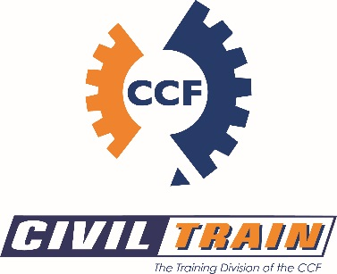
COMPLAINTS AND APPEAL FORM (Part A)
APPLICANT INFORMATION
Family Name: |  |  | Student Number:
Given Name(s):
Date of Birth: |  | Phone(mobile):  Phone(home):
Postal Address:
Town/City: | State: |  | Post Code:
Preferred E-mail:
Enrolled Course:
COMPLAINT AND APPEAL DETAILS
Complaint or Appeal relates to a:
Academic Matter – Have you taken up your complaint/appeal with your Trainer/Assessor?
□ Yes □ No
Non-Academic Matter – Have you raised this matter with an Civil Train RTO representative?
□ Yes □ No

Details of Complaint/Appeal:
Please provide a statement giving full details of your complaint/appeal
Your statement should include the following information:
- Detail of the Complaint/Appeal
- Name and title of people involved
- Dates and times of events
- The name of people or organisation you have approached in relation to your complaint/appeal
- The effect the complaint/appeal has had on you
- Copies of any documents relating to your complaint/appeal (e.g assessment documents, witness statements)

What is your desired outcome, which you believe would settle the complaint/appeal?
Details:

STUDENT DECLARATION
Have you?

Identified the type of complaint or appeal: □ Yes □ No
Attached relevant supporting documentation: □ Yes □ No

If you have answered NO for any of the above, please note that your application will not be assessed until the appropriate documentation is provided.

Declaration:
- I have read and understand the Civil Train Complaint and Appeal Policy and Procedure.
- I have read and understand the Civil Train Refund Policy and Procedure as it relates to this application.
- I declare that the information provided and submitted by me on this form along with any supporting document is accurate in all respects. I acknowledge that the provision of incorrect information or the withholding of relevant information relating to my application may delay the processing of my application or may result in the termination of my enrolment with the RTO (Civil Train).

Signature of applicant: |  |  |  | Date:

