A lot of things we do at work can create pollution and waste. This can put people and the environment at risk of harm.
From 1 July 2020, new laws will require all businesses to prevent and manage the risks of harm to people and the environment from their activities.
Use this tool to learn what actions you can take to manage the risks of your business causing harm to people and the environment. This isn’t a complete list of everything you can do, but it’s a good start.
How can I manage environmental risks?
You can use this risk management process to help you get started:
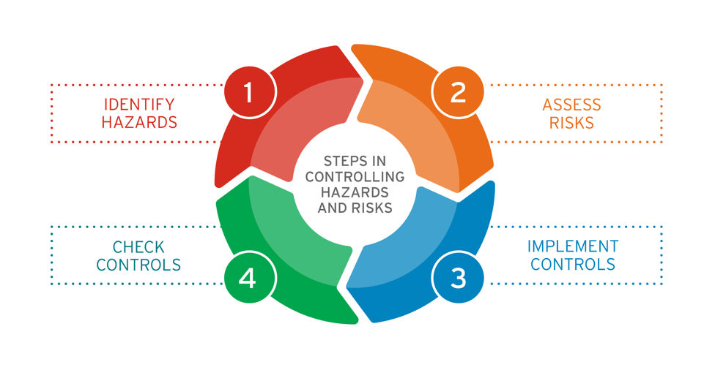
- Identify any hazards or activities at your business that could cause harm.
- Assess how severe the risk is, based on the likelihood of it happening and its consequence.
- Implement suitable risk control measures.
- Check controls regularly to make sure they are working.
Risk management resources
- Use the self-assessment tool on the next page to help you learn how to manage risks.
- Assessing and controlling risk: A guide for business (EPA publication 1695) has more information on risk management.
- EPA’s website, epa.vic.gov.au/for-business, has information and guidance relevant to your specific business activities.
- Sustainability Victoria’s website, sustainability.vic.gov.au/business, has good ideas for improving resource efficiency, including waste and recycling tips.
- Note: Some activities (e.g. storing and disposing of certain wastes) require permission from EPA. Visit epa.vic.gov.au for more information.

Self-assessment tool
Work out what could go wrong
- Identify hazards (e.g. chemical spills, excessive noise) and potential impacts (e.g. entering stormwater, disturbing neighbours) from your activities.
- Identify likelihood and seriousness of risk/impacts.
- Identify and implement risk control measures
(e.g. use drain guards, minimise plant/equipment noise out of business hours).
- Regularly check risk controls to make sure they are
working as planned.
Use plant and equipment correctly
(if you use any)
- Regularly maintain plant and equipment and keep records of this maintenance.
- Use and follow operating procedure/manuals.
- Monitor and routinely check plant and equipment (e.g. for leaks, that they aren’t too noisy etc.).
Provide information, instruction, training and supervision
- Induct all workers (including contractors) on the environmental risks on site.
- Train all workers (e.g. on waste management) before they undertake any activities with risk or use any risk control measures.
- Provide any relevant information about the nature
of the risks on site and how to use risk control measures.
- Supervise workers to ensure work is done in a way that avoids or minimises harm to people and
the environment.
Ensure waste and chemicals are handled, stored, used, transported and deposited correctly
- Keep up-to-date records and documents (e.g. safety data sheets) relating to chemicals stored or used at your business.
- Use correct storage techniques (e.g. bunding), and store oils and chemicals in closed containers.
- Use authorised waste transporters to collect hazardous waste (e.g. solvents, caustic cleaning chemicals).
- Use appropriate waste disposal facilities (e.g. EPA licensed facilities).
- Don’t put any liquid waste in the stormwater drain.
- Protect stormwater drains and keep them free of material (e.g. litter, dust) from accidental spills.
- Take e-waste to the right place.
Minimise harm if something goes wrong
- Install adequate systems and control measures
(e.g. fire alarms and extinguishers, overflow spill alarm, spill kits etc.).
- Develop and implement procedures for reporting pollution incidents and ‘near misses’.
- Report and act on pollution incidents and ‘near misses’, including notifying EPA where required.
- Review work procedures and training following incidents.
Add your own notes here:

